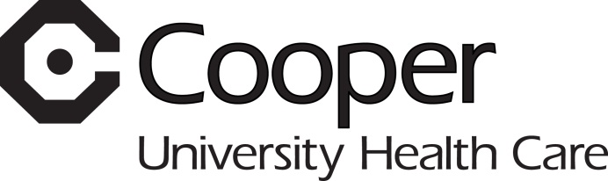
Employee Assistance Program

Workshop Listing

A NEW LOOK AT STRESS MANAGEMENT USING ACUPRESSURE FOR THE EMOTIONS – Participants will learn the technique of acupressure to reduce the negative emotions associated with anxiety. Acupressure has been found to be effective in mitigating the impact of phobias, test anxiety, and stress.

BALANCE, BOUNDARIES, AND BURNOUT – Recognize the need for balance both at work and at home, how to set appropriate boundaries, and identify the signs of stress, work stress triggers, learn coping skills and the 5 stages of burnout.

B-E-S-T COMMUNICATION STYLES – Have you ever wondered why it takes more energy to talk/work with one person than it is with another? In this interactive workshop you will learn about four communication styles; what your primary and secondary style of communication is; and become more aware of how your style impacts your relationships.

CONFLICT MANAGEMENT: CONFRONTATION WITHOUT ALIENATION – Are you uncomfortable with confrontation? Do you sit on the sidelines watching conflict happen around you? Would you like to learn some new techniques for resolving conflict and managing confrontation? Confrontation can be a positive event. Don’t think so; come find out how.

DEALING WITH CHALLENGING PEOPLE - Learn techniques on how to appropriately deal with challenging people and the barriers that may exist in successful conflict resolution.

EMOTIONAL INTELLIGENCE – Ever wonder why you are always getting “passed over”? Learn how to take control of your emotions and use them to your advantage.

IT’S HOW TO SAY IT - This workshop focuses on empathic vs. reactive interactions, constructive criticism, active listening and proven methods to smooth out communication.

VIOLENCE IN THE WORKPLACE (ONLY offered to those companies with a “Violence in the Workplace” policy and procedure) - Learn how to identify, prevent, and handle both verbal and physical violence in the workplace more effectively.

